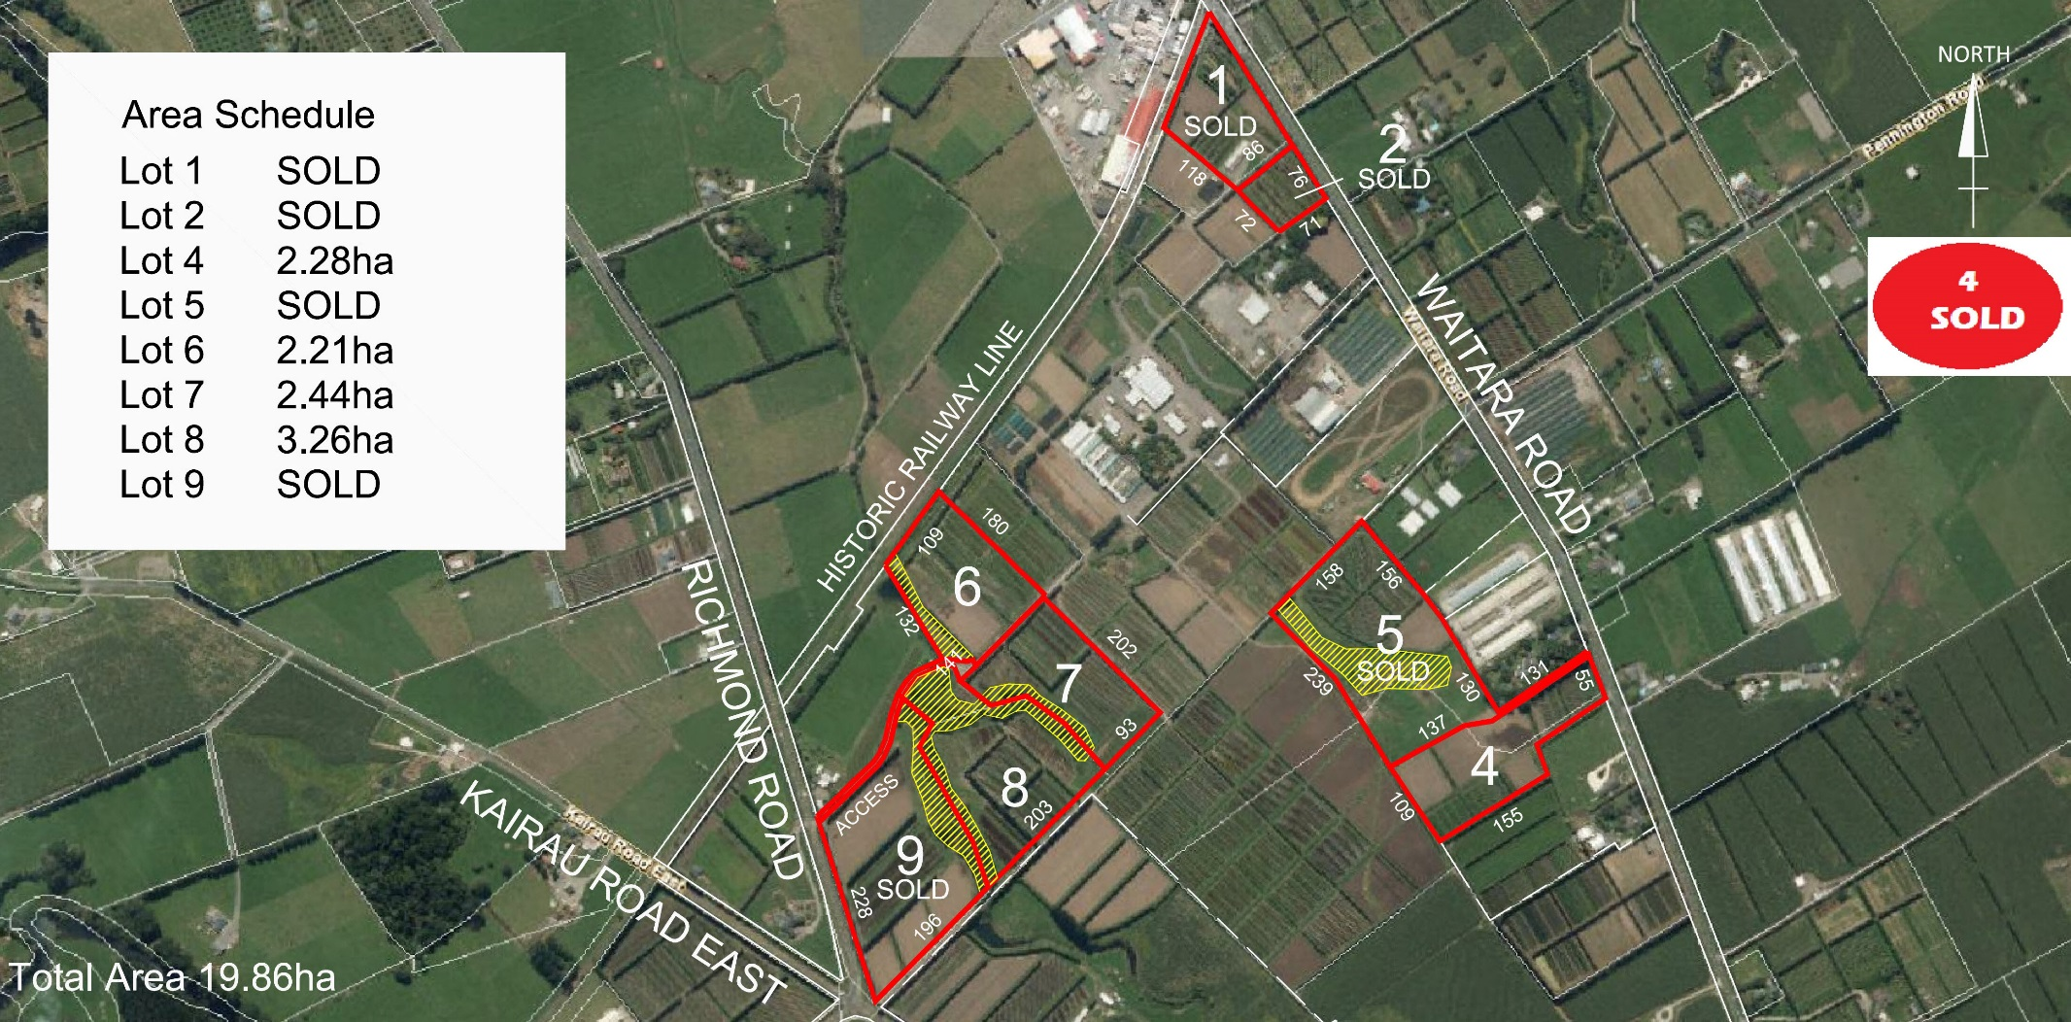

**5**

SOLD

SOLD

SOLD

SOLD

SOLD

SOLD

3.26ha

SOLD

SOLD