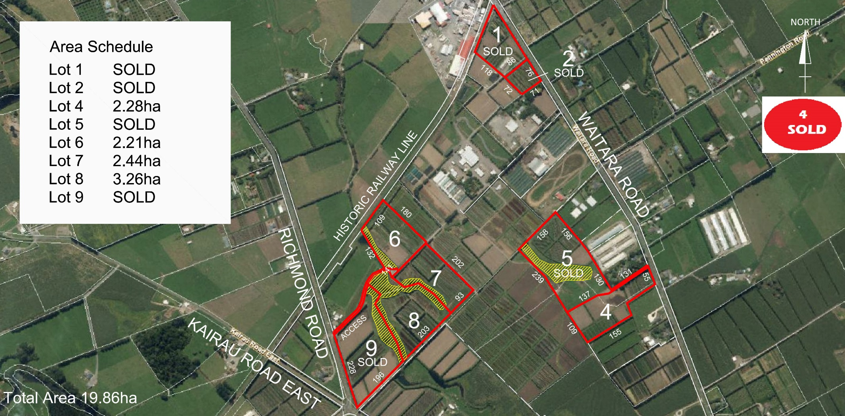

SOLD

SOLD

SOLD

SOLD

2.21ha

2.44ha

3.26ha

SOLD

**5**

**SOLD**

SOLD